Advanced Database Systems Lab (7CS371)

Assignment No. 10: Cassandra Clustering

1. Aim
To set up a multi-node Cassandra cluster on a single Windows machine using Docker and demonstrate a real-world IoT use case with monitoring.

2. System Setup
- OS: Windows 10
- Tool: Docker Desktop
- Database: Apache Cassandra 3.11

3. Cluster Setup

Step 1: Create Docker Network
docker network create cassandra-net

Step 2: Run Cassandra Nodes
docker run -d --name cass1 --network cassandra-net cassandra:3.11
docker run -d --name cass2 --network cassandra-net -e CASSANDRA_SEEDS=cass1 cassandra:3.11
docker run -d --name cass3 --network cassandra-net -e CASSANDRA_SEEDS=cass1 cassandra:3.11

Step 3: Verify Cluster
docker exec -it cass1 nodetool status

Output:
All nodes should be in UN (Up & Normal) state.

4. Cluster Configuration

Rename Cluster
UPDATE system.local SET cluster_name = '2026GRPXX' WHERE key = 'local';

5. Use Case: Weather Station IoT Data

Problem Statement
Multiple weather stations record temperature every 5 minutes and send data to the Cassandra cluster. The system should allow efficient storage and retrieval of time-series data.

6. Database Design

Keyspace Creation
CREATE KEYSPACE weather_data
WITH replication = {'class': 'SimpleStrategy', 'replication_factor': 3};

Use Keyspace
USE weather_data;

Table Creation
CREATE TABLE temperature_data (
weatherStationID text,
recorded_at timestamp,
temperature float,
location text,
PRIMARY KEY (weatherStationID, recorded_at)
) WITH CLUSTERING ORDER BY (recorded_at DESC);

7. Data Insertion
INSERT INTO temperature_data VALUES ('WS001', toTimestamp(now()), 32.5, 'Pune');
INSERT INTO temperature_data VALUES ('WS001', toTimestamp(now()), 33.1, 'Pune');
INSERT INTO temperature_data VALUES ('WS002', toTimestamp(now()), 28.4, 'Mumbai');

8. Queries

Retrieve Data
SELECT * FROM temperature_data WHERE weatherStationID='WS001';

Latest Record
SELECT * FROM temperature_data WHERE weatherStationID='WS001' LIMIT 1;

9. Cluster Monitoring
Due to unavailability of DataStax OpsCenter Docker images, cluster monitoring was performed using built-in Cassandra tools.

Commands Used

Node Status
docker exec -it cass1 nodetool status

Cluster Info
docker exec -it cass1 nodetool describecluster

Node Details
docker exec -it cass1 nodetool info

10. Observations
- All nodes successfully joined the cluster.
- Data is distributed across nodes using partitioning.
- Replication factor ensures fault tolerance.
- Queries executed successfully from multiple nodes.

11. Result
Successfully implemented a multi-node Cassandra cluster and demonstrated IoT-based weather data storage and retrieval with cluster monitoring.

12. Conclusion
Cassandra provides high scalability and fault tolerance for distributed applications. The experiment demonstrated how NoSQL databases efficiently handle time-series IoT data.

13. Screenshots to Attach
- Cluster status (nodetool)
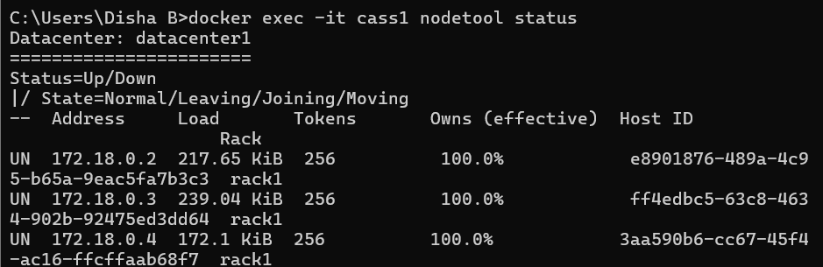
- Keyspace creation
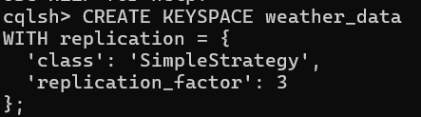
- Table structure
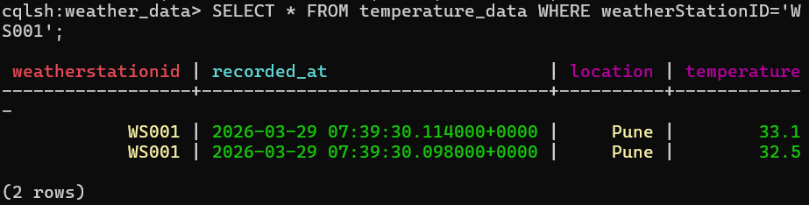
- Insert queries
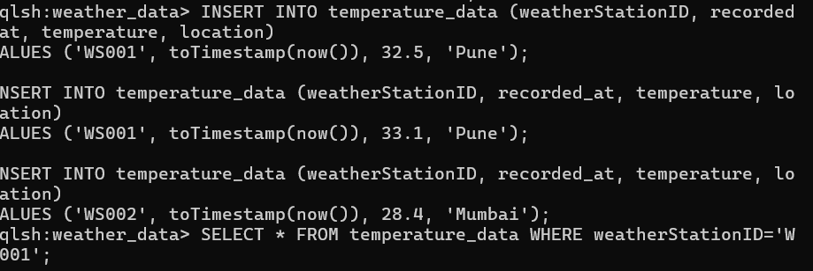
- Query results
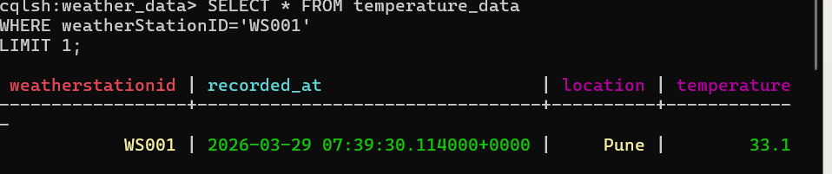

/*Microsoft Windows [Version 10.0.26200.8037]
(c) Microsoft Corporation. All rights reserved.

C:\Users\Disha B>docker run -d --name cass1 -p 9042:9042 cassandra:3.11
Unable to find image 'cassandra:3.11' locally
3.11: Pulling from library/cassandra
5d42da29b261: Pull complete
fa94125d190e: Pull complete
bf175d9fcc0a: Pull complete
0497a703e222: Pull complete
c39795272d2d: Pull complete
7e27b670a0f5: Pull complete
5a2e2c2fe7e2: Pull complete
7e49dc6156b0: Pull complete
9aca2daeac75: Pull complete
c5ca755942a5: Pull complete
c53675a133c6: Pull complete
ebead0826a0a: Download complete
0058fd1db4ab: Download complete
Digest: sha256:9a14b18eb658851e8939cfdeca8fcbca389f5f0d00fca4a995d80b6accfcbd96
Status: Downloaded newer image for cassandra:3.11
f5719bc7b4a51c6dfa0dafe6ac423b108cd044ca97c5768e66656a99d7642e5b

C:\Users\Disha B>docker run -d --name cass2 -p 9043:9042 cassandra:3.11
297ec430b66d9f7b86c1c37ca254cc6baa0e511c2c00d5c6ebb88a3214a49865

C:\Users\Disha B>docker run -d --name cass3 -p 9044:9042 cassandra:3.11
6e609c6fd3c5cf6b4db0817587242ce4a5035b926ec3ae69b7f11e6d205695e4

C:\Users\Disha B>docker ps
CONTAINER ID IMAGE COMMAND CREATED STATUS PORTS NAMES
6e609c6fd3c5 cassandra:3.11 "docker-entrypoint.s…" 16 seconds ago Up 15 seconds 0.0.0.0:9044->9042/tcp, [::]:9044->9042/tcp cass3
297ec430b66d cassandra:3.11 "docker-entrypoint.s…" 34 seconds ago Up 33 seconds 0.0.0.0:9043->9042/tcp, [::]:9043->9042/tcp cass2
f5719bc7b4a5 cassandra:3.11 "docker-entrypoint.s…" 2 minutes ago Up 2 minutes 0.0.0.0:9042->9042/tcp, [::]:9042->9042/tcp cass1

C:\Users\Disha B>docker network create cassandra-net
4655851738e6d4fd637141a9a1c0c0f0ddea02fc5ffb04f43e12799ce9293cc3

C:\Users\Disha B>docker stop cass1 cass2 cass3
cass1
cass2
cass3

C:\Users\Disha B>docker rm cass1 cass2 cass3
cass1
cass2
cass3

C:\Users\Disha B>docker run -d --name cass1 --network cassandra-net cassandra:3.11
63e162affe586261ea4c788e14d9e2ed8cebb0202ee9dda339f441e42ffc3518

C:\Users\Disha B>docker run -d --name cass2 --network cassandra-net -e CASSANDRA_SEEDS=cass1 cassandra:3.11
a3a324b4ad8b2481df890430715550d2431afc1e2023b7869a93f09e8cf9824b

C:\Users\Disha B>docker run -d --name cass3 --network cassandra-net -e CASSANDRA_SEEDS=cass1 cassandra:3.11
13412abeede1b899668587ff4edf126f9e87b97e0f761a18a5b33743ff7a255f

C:\Users\Disha B>docker exec -it cass1 nodetool status
Datacenter: datacenter1
=======================
Status=Up/Down
|/ State=Normal/Leaving/Joining/Moving
-- Address Load Tokens Owns (effective) Host ID Rack
UN 172.18.0.2 70.9 KiB 256 100.0% e8901876-489a-4c95-b65a-9eac5fa7b3c3 rack1
UJ 172.18.0.3 20.59 KiB 256 ? ff4edbc5-63c8-4634-902b-92475ed3dd64 rack1

C:\Users\Disha B>docker exec -it cass1 cqlsh
Connected to Test Cluster at 127.0.0.1:9042.
[cqlsh 5.0.1 | Cassandra 3.11.19 | CQL spec 3.4.4 | Native protocol v4]
Use HELP for help.
cqlsh> UPDATE system.local
SET cluster_name = '2026GRPXX'
WHERE key = 'local';
cqlsh> docker restart cass1 cass2 cass3
...
...
...
...
Statements are terminated with a ';'. You can press CTRL-C to cancel an incomplete statement.
cqlsh> docker restart cass1 cass2 cass3;
SyntaxException: line 1:0 no viable alternative at input 'docker' ([docker]...)
cqlsh> docker restart cass1 cass2 cass3;
SyntaxException: line 1:0 no viable alternative at input 'docker' ([docker]...)
cqlsh> exit;

C:\Users\Disha B>docker restart cass1 cass2 cass3
cass1
cass2
cass3

C:\Users\Disha B>docker exec -it cass1 nodetool status
Datacenter: datacenter1
=======================
Status=Up/Down
|/ State=Normal/Leaving/Joining/Moving
-- Address Load Tokens Owns (effective) Host ID Rack
UN 172.18.0.2 171.93 KiB 256 100.0% e8901876-489a-4c95-b65a-9eac5fa7b3c3 rack1
UN 172.18.0.3 193.34 KiB 256 100.0% ff4edbc5-63c8-4634-902b-92475ed3dd64 rack1

C:\Users\Disha B>docker exec -it cass1 cqlsh
Connected to Test Cluster at 127.0.0.1:9042.
[cqlsh 5.0.1 | Cassandra 3.11.19 | CQL spec 3.4.4 | Native protocol v4]
Use HELP for help.
cqlsh> CREATE KEYSPACE weather_data
WITH replication = {
'class': 'SimpleStrategy',
'replication_factor': 3
};
cqlsh> USE weather_data;
cqlsh:weather_data> CREATE TABLE temperature_data (
weatherStationID text,
recorded_at timestamp,
temperature float,
location text,
PRIMARY KEY (weatherStationID, recorded_at)
) WITH CLUSTERING ORDER BY (recorded_at DESC);
cqlsh:weather_data> INSERT INTO temperature_data (weatherStationID, recorded_at, temperature, location)
VALUES ('WS001', toTimestamp(now()), 32.5, 'Pune');

INSERT INTO temperature_data (weatherStationID, recorded_at, temperature, location)
VALUES ('WS001', toTimestamp(now()), 33.1, 'Pune');

INSERT INTO temperature_data (weatherStationID, recorded_at, temperature, location)
VALUES ('WS002', toTimestamp(now()), 28.4, 'Mumbai');
cqlsh:weather_data> SELECT * FROM temperature_data WHERE weatherStationID='WS001';

weatherstationid | recorded_at | location | temperature
------------------+---------------------------------+----------+-------------
WS001 | 2026-03-29 07:39:30.114000+0000 | Pune | 33.1
WS001 | 2026-03-29 07:39:30.098000+0000 | Pune | 32.5

(2 rows)
cqlsh:weather_data> SELECT * FROM temperature_data
WHERE weatherStationID='WS001'
LIMIT 1;

weatherstationid | recorded_at | location | temperature
------------------+---------------------------------+----------+-------------
WS001 | 2026-03-29 07:39:30.114000+0000 | Pune | 33.1

(1 rows)
cqlsh:weather_data> docker exec -it cass1 nodetool status
...
cqlsh:weather_data>
cqlsh:weather_data> exit;

C:\Users\Disha B>docker exec -it cass1 nodetool status
Datacenter: datacenter1
=======================
Status=Up/Down
|/ State=Normal/Leaving/Joining/Moving
-- Address Load Tokens Owns (effective) Host ID Rack
UN 172.18.0.2 217.65 KiB 256 100.0% e8901876-489a-4c95-b65a-9eac5fa7b3c3 rack1
UN 172.18.0.3 239.04 KiB 256 100.0% ff4edbc5-63c8-4634-902b-92475ed3dd64 rack1
UN 172.18.0.4 172.1 KiB 256 100.0% 3aa590b6-cc67-45f4-ac16-ffcffaab68f7 rack1

C:\Users\Disha B>docker exec -it cass1 nodetool describecluster
Cluster Information:
Name: Test Cluster
Snitch: org.apache.cassandra.locator.SimpleSnitch
DynamicEndPointSnitch: enabled
Partitioner: org.apache.cassandra.dht.Murmur3Partitioner
Schema versions:
d77a7e42-b9a1-35b4-881f-3974a0926c3c: [172.18.0.2, 172.18.0.3, 172.18.0.4]

C:\Users\Disha B>docker exec -it cass2 cqlsh
docker exec -it cass3 cqlshConnected to Test Cluster at 127.0.0.1:9042.
[cqlsh 5.0.1 | Cassandra 3.11.19 | CQL spec 3.4.4 | Native protocol v4]
Use HELP for help.
cqlsh> docker exec -it cass3 cqlsh
...
cqlsh> SELECT * FROM weather_data.temperature_data;

weatherstationid | recorded_at | location | temperature
------------------+---------------------------------+----------+-------------
WS001 | 2026-03-29 07:39:30.114000+0000 | Pune | 33.1
WS001 | 2026-03-29 07:39:30.098000+0000 | Pune | 32.5
WS002 | 2026-03-29 07:39:30.116000+0000 | Mumbai | 28.4

(3 rows)
cqlsh> exit;

C:\Users\Disha B>docker exec -it cass3 cqlsh
Connected to Test Cluster at 127.0.0.1:9042.
[cqlsh 5.0.1 | Cassandra 3.11.19 | CQL spec 3.4.4 | Native protocol v4]
Use HELP for help.
cqlsh> SELECT * FROM weather_data.temperature_data;

weatherstationid | recorded_at | location | temperature
------------------+---------------------------------+----------+-------------
WS001 | 2026-03-29 07:39:30.114000+0000 | Pune | 33.1
WS001 | 2026-03-29 07:39:30.098000+0000 | Pune | 32.5
WS002 | 2026-03-29 07:39:30.116000+0000 | Mumbai | 28.4

(3 rows)
cqlsh> exit;

C:\Users\Disha B>docker run -d --name opscenter \
docker: invalid reference format

Run 'docker run --help' for more information

C:\Users\Disha B>-p 8888:8888 \
'-p' is not recognized as an internal or external command,
operable program or batch file.

C:\Users\Disha B>--network cassandra-net \
'--network' is not recognized as an internal or external command,
operable program or batch file.

C:\Users\Disha B>docker run -d --name opscenter\ -p 8888:8888 \ --network cassandra-net\datastax/dse-opscenter:latest
docker: invalid reference format

Run 'docker run --help' for more information

C:\Users\Disha B>docker run -d --name opscenter -p 8888:8888 --network cassandra-net datastax/dse-opscenter:latest
Unable to find image 'datastax/dse-opscenter:latest' locally
docker: Error response from daemon: failed to resolve reference "docker.io/datastax/dse-opscenter:latest": docker.io/datastax/dse-opscenter:latest: not found

Run 'docker run --help' for more information

C:\Users\Disha B>docker run -d --name opscenter -p 8888:8888 --network cassandra-net datastax/opscenter:6.8.0
Unable to find image 'datastax/opscenter:6.8.0' locally
docker: Error response from daemon: pull access denied for datastax/opscenter, repository does not exist or may require 'docker login'

Run 'docker run --help' for more information

C:\Users\Disha B>docker run -d --name cassandra-web -p 3000:3000 --network cassandra-net -e CASSANDRA_HOST=cass1 -e CASSANDRA_PORT=9042 instaclustr/cassandra-web:latest
Unable to find image 'instaclustr/cassandra-web:latest' locally
docker: Error response from daemon: pull access denied for instaclustr/cassandra-web, repository does not exist or may require 'docker login'

Run 'docker run --help' for more information

C:\Users\Disha B>docker run -d --name cassandra-web -p 3000:80 --network cassandra-net -e CASSANDRA_HOSTS=cass1 ipushc/cassandra-web
Unable to find image 'ipushc/cassandra-web:latest' locally
latest: Pulling from ipushc/cassandra-web
f4508b58ac7e: Pull complete
6097bfa160c1: Pull complete
68c8b2f4f118: Pull complete
ec35cb5a4413: Pull complete
a0dc9b5847f6: Pull complete
54b2955824ef: Pull complete
3663b45a43ea: Pull complete
71853c2530fa: Pull complete
b41237d2d590: Download complete
Digest: sha256:fa3e0c66c28999aa65f454e008f86a147de40a4fe78c1a51108099e0e22e4384
Status: Downloaded newer image for ipushc/cassandra-web:latest
b33b317812f88c86ae306558d4fa9a0ac57d0f274c6cbfa9efdf802db821b6fa

C:\Users\Disha B>docker ps
CONTAINER ID IMAGE COMMAND CREATED STATUS PORTS NAMES
13412abeede1 cassandra:3.11 "docker-entrypoint.s…" About an hour ago Up 15 minutes 7000-7001/tcp, 7199/tcp, 9042/tcp, 9160/tcp cass3
a3a324b4ad8b cassandra:3.11 "docker-entrypoint.s…" About an hour ago Up 15 minutes 7000-7001/tcp, 7199/tcp, 9042/tcp, 9160/tcp cass2
63e162affe58 cassandra:3.11 "docker-entrypoint.s…" About an hour ago Up 15 minutes 7000-7001/tcp, 7199/tcp, 9042/tcp, 9160/tcp cass1

C:\Users\Disha B>http://localhost:3000
'http:' is not recognized as an internal or external command,
operable program or batch file.

C:\Users\Disha B>docker inspect -f "{{range .NetworkSettings.Networks}}{{.IPAddress}}{{end}}" cass1
172.18.0.2

C:\Users\Disha B>docker ps -a
CONTAINER ID IMAGE COMMAND CREATED STATUS PORTS NAMES
b33b317812f8 ipushc/cassandra-web "./service" 3 minutes ago Exited (1) 3 minutes ago cassandra-web
13412abeede1 cassandra:3.11 "docker-entrypoint.s…" 2 hours ago Up 18 minutes 7000-7001/tcp, 7199/tcp, 9042/tcp, 9160/tcp cass3
a3a324b4ad8b cassandra:3.11 "docker-entrypoint.s…" 2 hours ago Up 18 minutes 7000-7001/tcp, 7199/tcp, 9042/tcp, 9160/tcp cass2
63e162affe58 cassandra:3.11 "docker-entrypoint.s…" 2 hours ago Up 18 minutes 7000-7001/tcp, 7199/tcp, 9042/tcp, 9160/tcp cass1

C:\Users\Disha B>docker logs cassandra-web
{"time":"2026-03-29T07:52:35.610286556Z","level":"INFO","prefix":"-","file":"main.go","line":"121","message":"Cofing 設定成功"}
2026/03/29 07:52:43 gocql: dns error: lookup cassandra on 127.0.0.11:53: no such host
{"time":"2026-03-29T07:52:43.641050971Z","level":"FATAL","prefix":"-","file":"main.go","line":"144","message":"gocql: unable to create session: failed to resolve any of the provided hostnames"}

C:\Users\Disha B>docker rm cassandra-web
cassandra-web

C:\Users\Disha B>docker run -d --name cassandra-web -p 3000:80 --network cassandra-net -e CASSANDRA_HOST=172.18.0.2 -e CASSANDRA_HOSTS=172.18.0.2 ipushc/cassandra-web
1bfbd4b9295a62e854391fa935519667446f607d156d39767368a95be5a5a100

C:\Users\Disha B>docker ps
CONTAINER ID IMAGE COMMAND CREATED STATUS PORTS NAMES
1bfbd4b9295a ipushc/cassandra-web "./service" 11 seconds ago Up 10 seconds 0.0.0.0:3000->80/tcp, [::]:3000->80/tcp cassandra-web
13412abeede1 cassandra:3.11 "docker-entrypoint.s…" 2 hours ago Up 20 minutes 7000-7001/tcp, 7199/tcp, 9042/tcp, 9160/tcp cass3
a3a324b4ad8b cassandra:3.11 "docker-entrypoint.s…" 2 hours ago Up 20 minutes 7000-7001/tcp, 7199/tcp, 9042/tcp, 9160/tcp cass2
63e162affe58 cassandra:3.11 "docker-entrypoint.s…" 2 hours ago Up 20 minutes 7000-7001/tcp, 7199/tcp, 9042/tcp, 9160/tcp cass1

C:\Users\Disha B>docker exec -it cass1 nodetool status
Datacenter: datacenter1
=======================
Status=Up/Down
|/ State=Normal/Leaving/Joining/Moving
-- Address Load Tokens Owns (effective) Host ID Rack
UN 172.18.0.2 217.65 KiB 256 100.0% e8901876-489a-4c95-b65a-9eac5fa7b3c3 rack1
UN 172.18.0.3 239.04 KiB 256 100.0% ff4edbc5-63c8-4634-902b-92475ed3dd64 rack1
UN 172.18.0.4 172.1 KiB 256 100.0% 3aa590b6-cc67-45f4-ac16-ffcffaab68f7 rack1

C:\Users\Disha B>*/

